**Project – Blades**

By,

Andrew Abraham

**Overview:**

5 main datasets were used for this project. Dataset name and level mentioned below:

1. Customer data (Level: PanID, StoreID, Week, UPC)
2. Store data (Level: StoreID, Week, UPC)
3. Customer Information (Level: PanID)
4. Store Information (Level: StoreID)
5. Product Information (Level: UPC)

**Executive Summary**

Throughout the analysis, recommendations were made for the brand Gillette, owned by Proctor & Gamble. The main goal was to provide insights to the marketing department of Gillette on brand expansion and customers acquisition in its least performing markets.

**Analysis 1**

**Objective:**

To find the top performing brands, products and markets in which Procter and Gamble is performing the least. Note that all products under P&G are of the brand Gillette.

Above chart shows the market share that each company has in the blades market. Gillette products leads the market with 70% share; which is more than 4 times the share of the second-best company, Energizer Holdings Inc., which comprises of 15% of the share. All the rest have less than 10% of total share each.

It is found that products of brand Gillette (owned by P&G) are most favoured by customers and are compare with the products of Schick (owned by Energizer)

Gillette Mach 3 is the leading product that customers buy and constitutes to 34% of total revenue of Procter & Gamble. The second-most favoured product is Gillette Sensor Excel with about 11% share.

For Energizer Holdings, the product Schick Slim Twin contributes the most revenue i.e. 37% of total share followed by Schick Xtreme III which constitutes about 21% of the total revenue.

The average coverage of the bottom five markets of Gillette is around 63%, i.e. 7% lower than Gillette’s overall market share.

**Recommendations:**

1. Invest in continuous marketing and sustaining brand image of the top 3 products of Gillette (Mach 3, Sensor Excel, Sensor) as they contribute to more than 50% of the total revenue
2. Invest in marketing and customer acquisition in the weaker markets to enhance market dominance and raising it in par with the top markets

**Analysis 2**

**Objective:**

To gauge the effect of product featuring and product display on sales in the low performing markets.

A fixed effect model was run controlling for product and time effects, predicting product sales and considering weighted product variant price, display sizes and feature sizes as independent variables. A random effects model was initially run but was rejected after testing for equality of coefficient estimates by the Hausman test. Below is the SAS output result for the ‘fixed two’ regression:

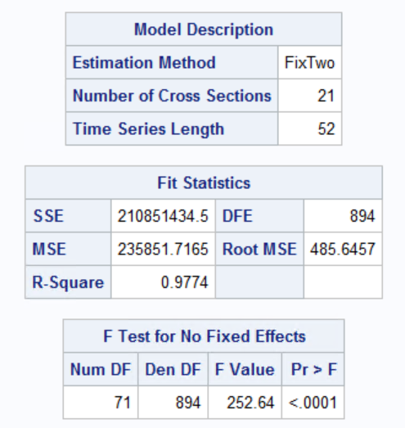

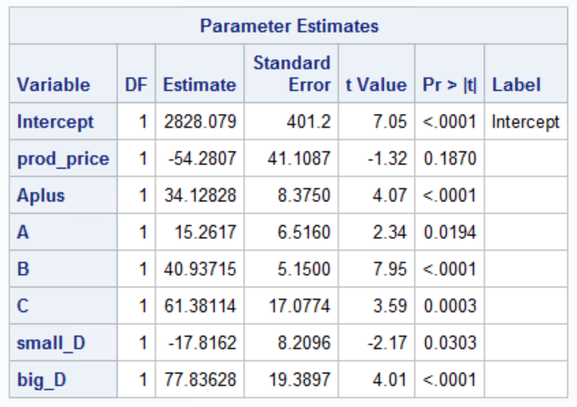

All coefficient estimates are found to be significant at a confidence level of 95%. Setting up a big display is associated with a $78 increment in sales per week than without any display, controlling for all other factors. All sizes of the featured displays were associated with a positive increment in sales, after controlling for all other factors. The largest of the increments is contributed by the smallest feature size as compared to the larger sizes and when compared with no feature at all.

**Recommendations:**

1. Frequent displays of the popular and flagship products should be set up on display at stores in the low performing markets to boost sales
2. Products should be advertised with multiple small sized features as compared to larger sizes, especially if the larger features are more than 2 times as expensive as the smaller ones

**Analysis 3**

**Objective:**

To discern patterns within customer demographics and spending patterns to understand factors affecting the choice preference between Gillette and its competitors.

A logistic regression was designed and modelled to predict choice preference with independent variables as number of units purchased, outlet type, dollars spent, combined pre-tax income, family size, household race, male occupation type, female age group and marital status.

Below are the steps taken to create the model:

1. Data Pre-processing

All the required data was gathered onto one central table from the various sources. The variables were then checked for correlation and some that were irrelevant for the analysis were then dropped

1. Building Model

A column for the dependant variable was then formed – ‘Brand’. Products of brand Gillette contained the value ‘Gillette’ and all other brands were labelled as ‘Others’.

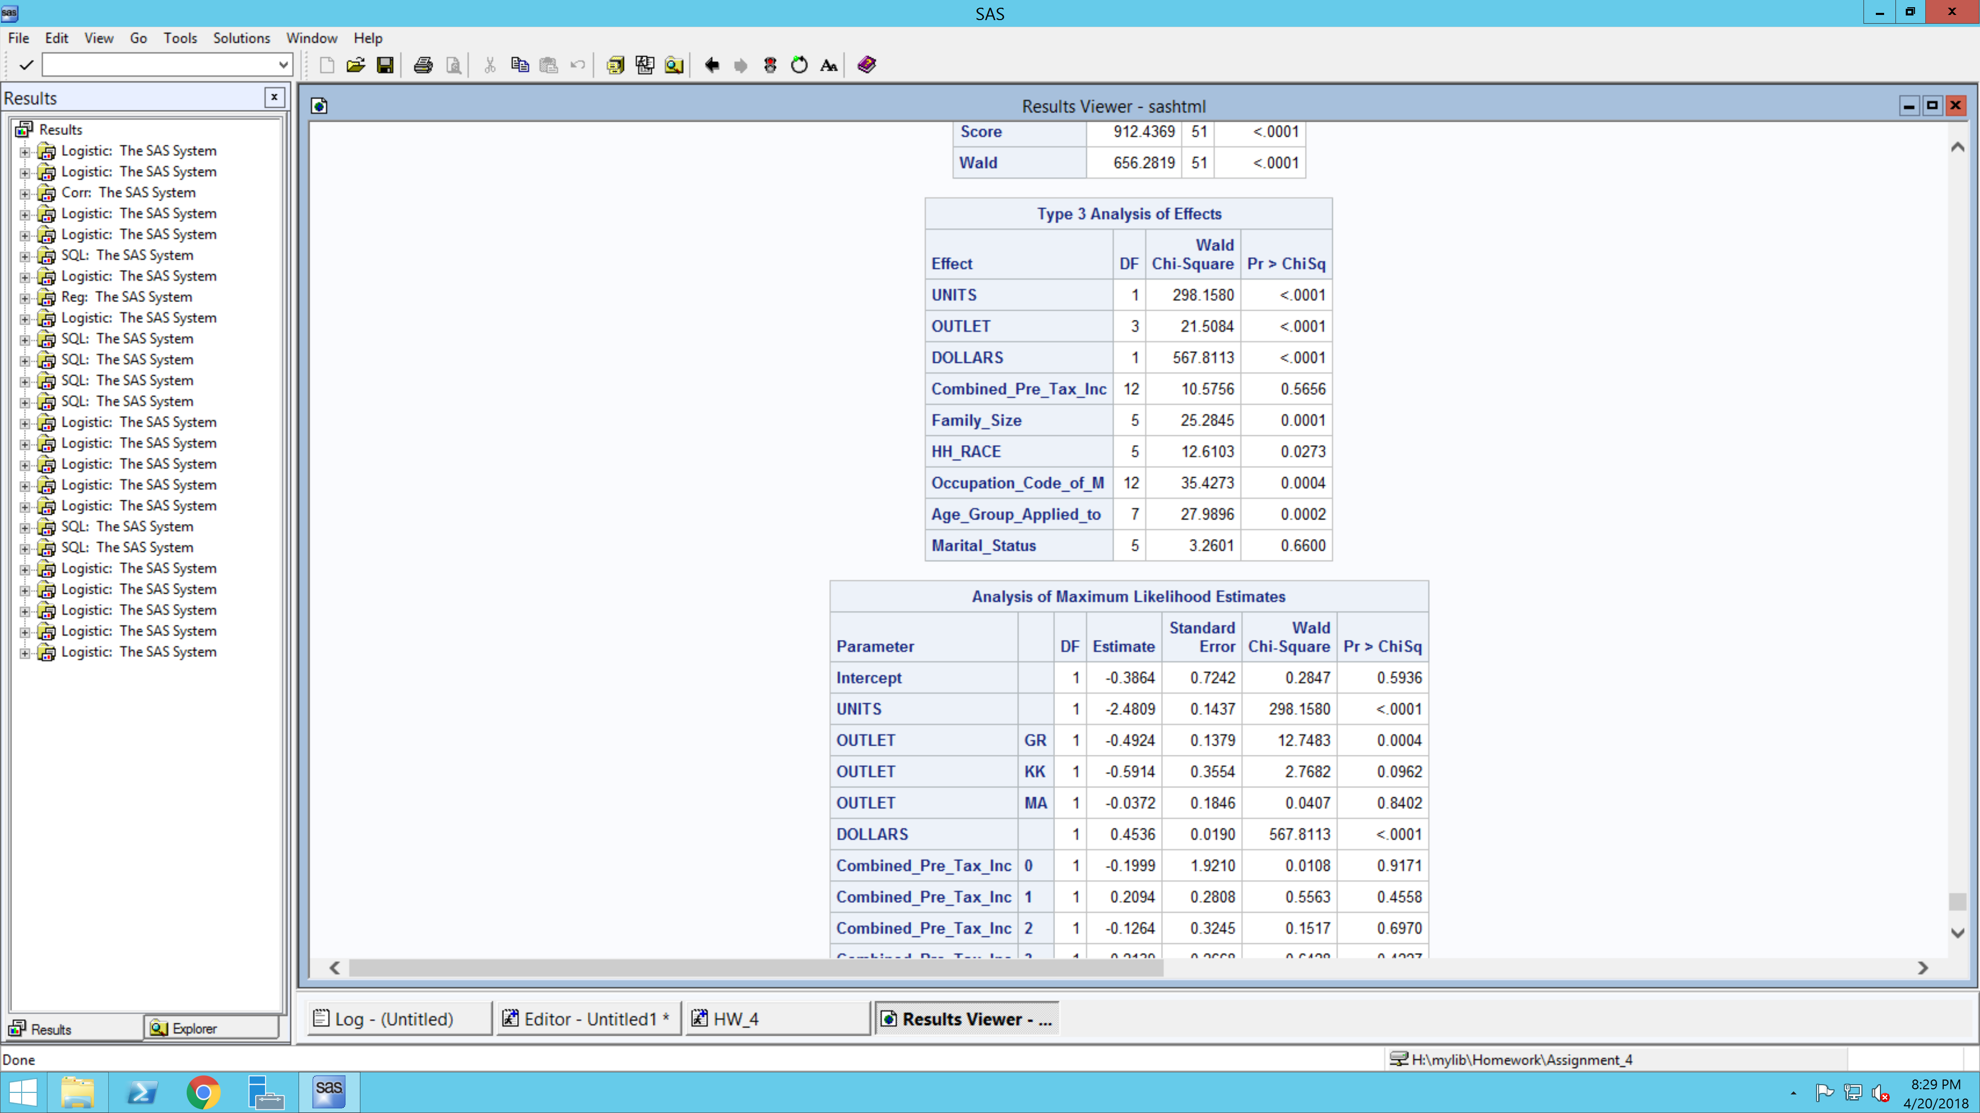



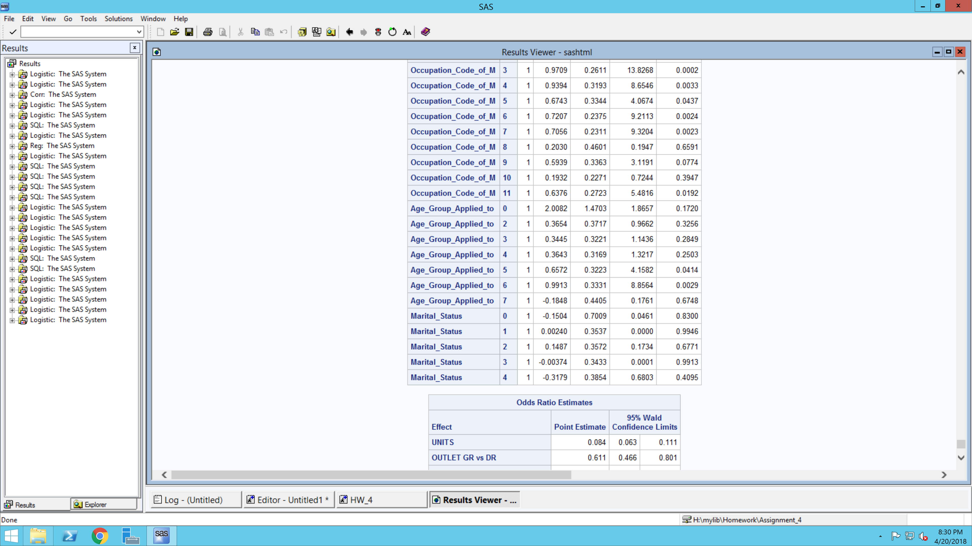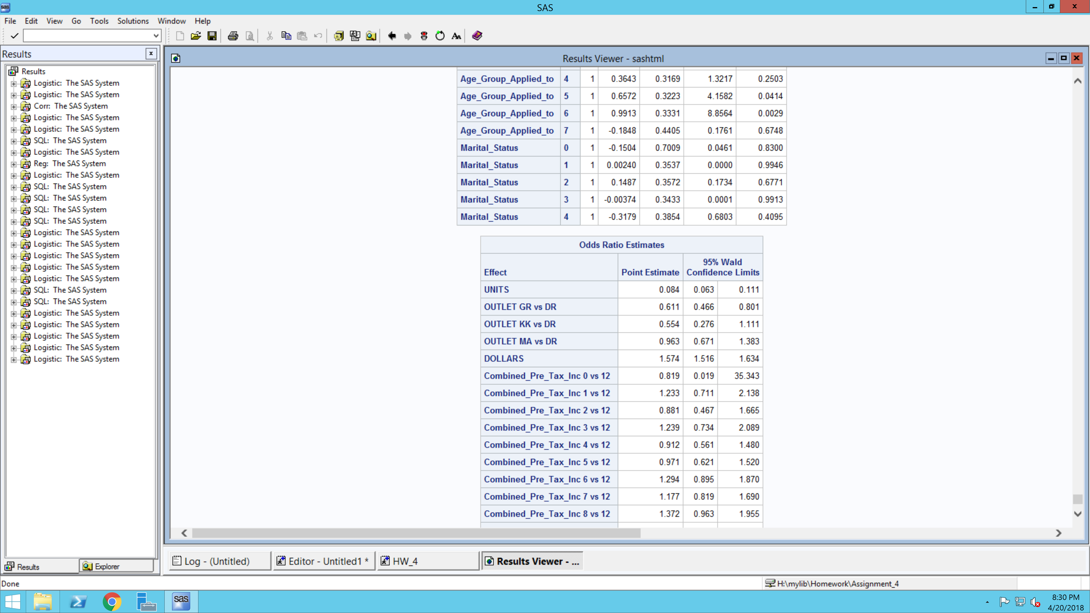

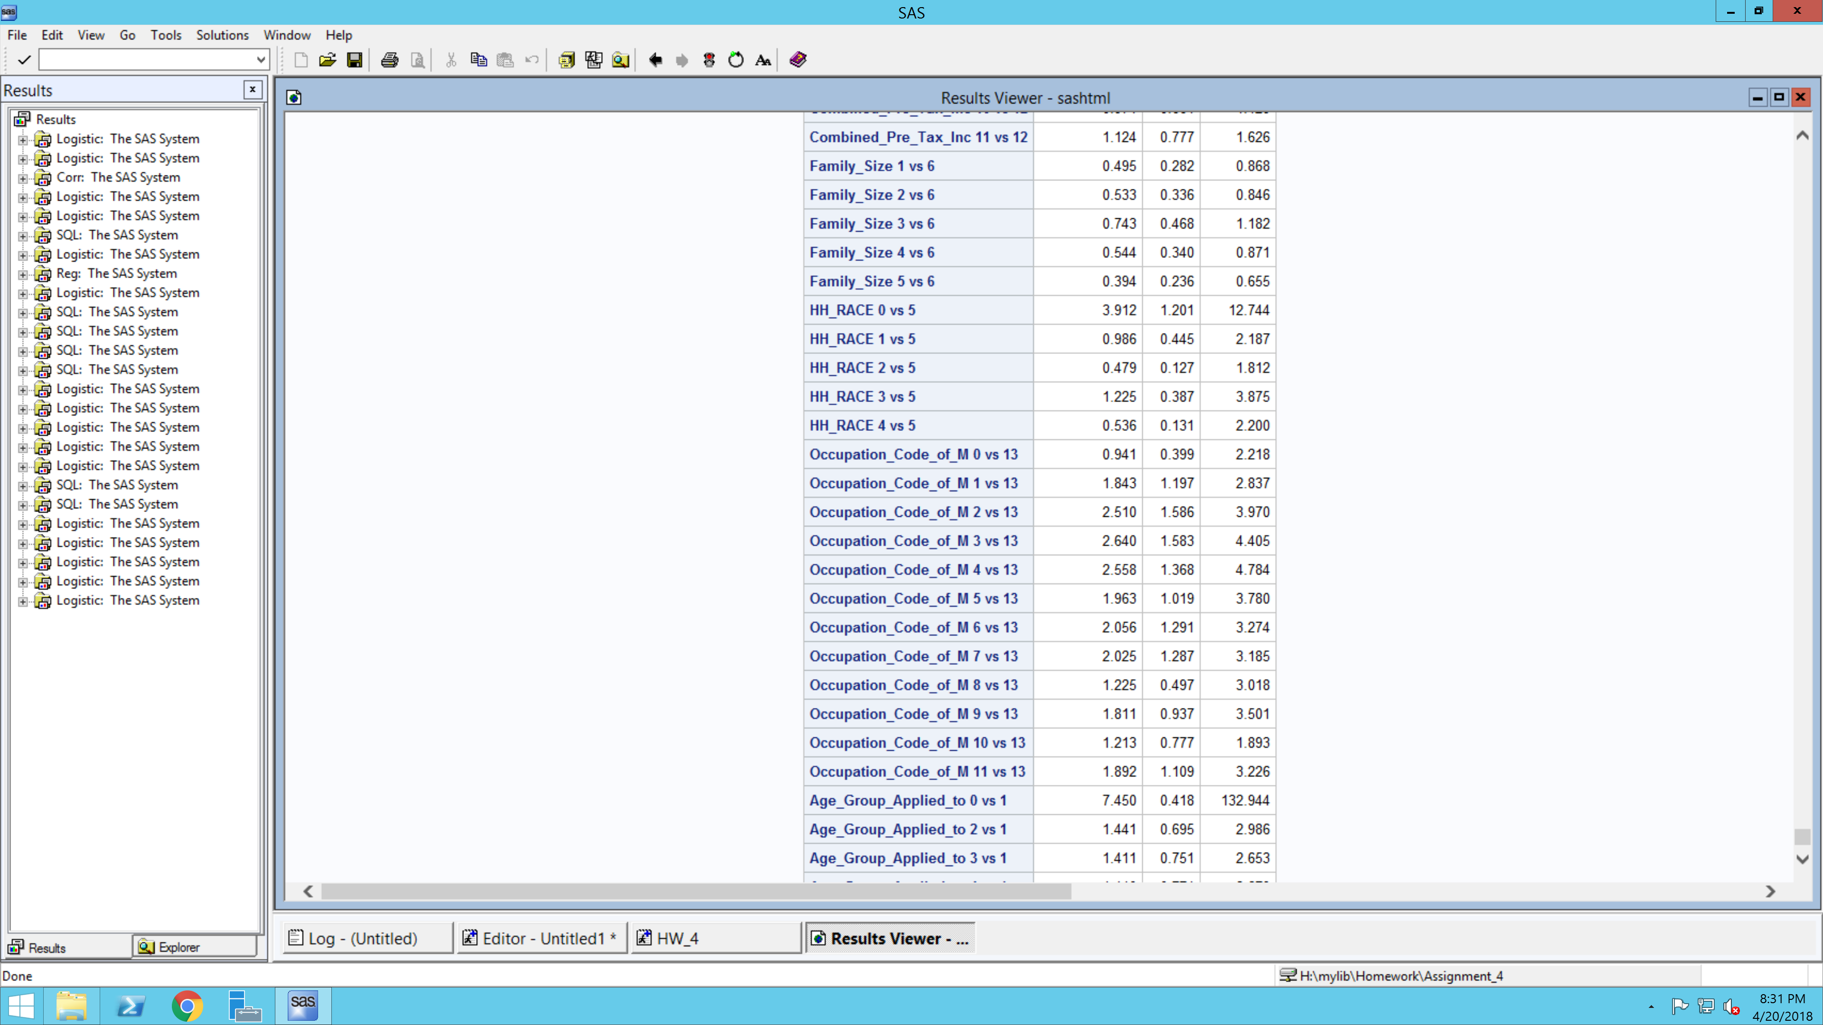

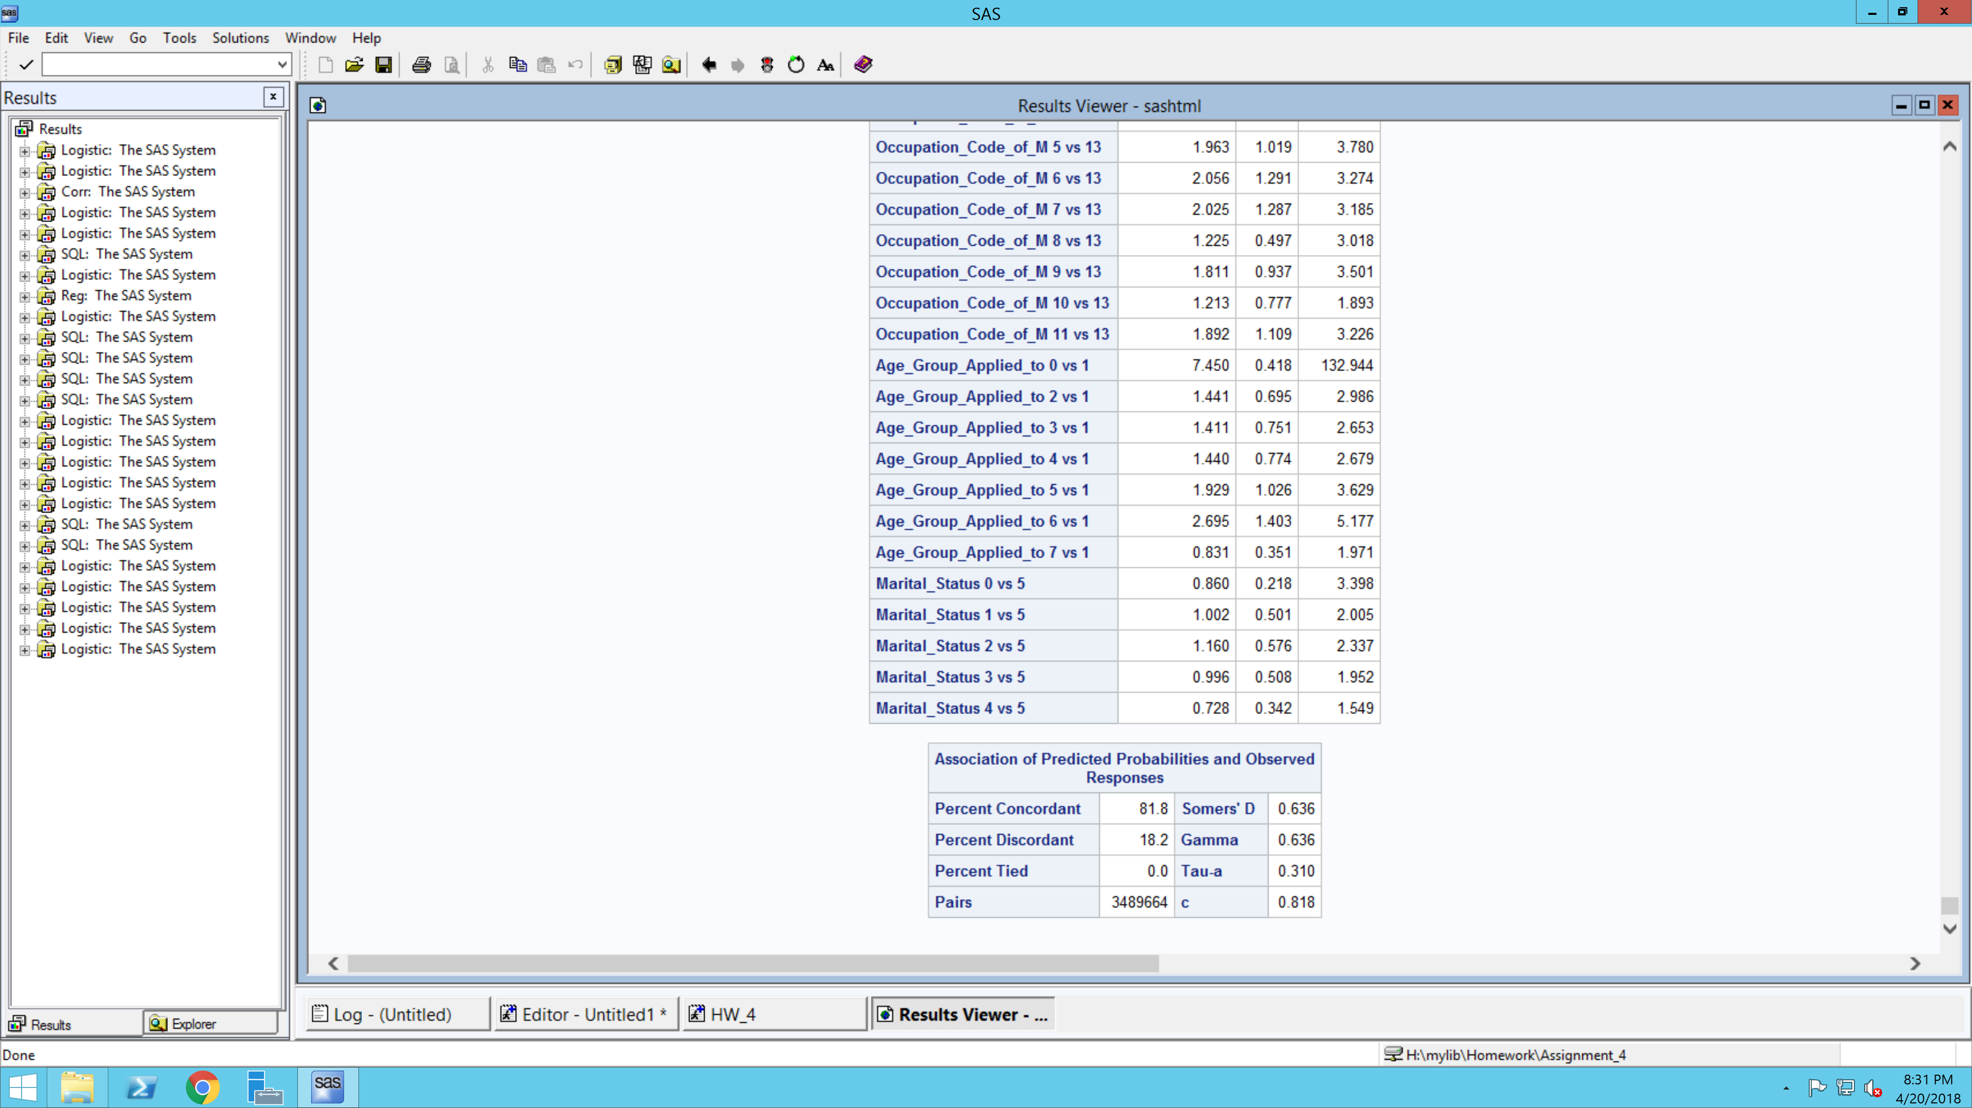



The significant variables from the above model are units purchased, outlet type, dollars spent, family size, female age group and male occupation type.

Below are the important interpretations that are were derived from the mode.

1. Effect on dollars spent:

An additional dollar spent by customer is associated with a 57.4% increase in the odds ratio of choosing the brand Gillette as compared to other brands.

1. Effect of units purchased:

A unit increase in the quantity purchased by the customer is associated with a 92% decrement in the odds ratio of choosing the brand Gillette as compared to other brands.

1. Effect of family size:

The odds ratio of customer purchasing a Gillette brand from a grocery store decreases by 39% as compared to customers purchasing it from a drug store.

The odds ratio of customer purchasing a Gillette brand blade who has a family size of 1 decrease by 50% as compared to the customer with a family size of 6 or more people.

The odds ratio of customer purchasing a Gillette brand blade who has a family size of 2 decreases by 47% as compared to the customer with a family size of 6 or more people.

Similarly, all other family size groups show a decrement in odds ratio when compared with a family size of 6 or more people.

1. Effect of occupation

Below are the occupational codes to interpret the SAS output:

0 = 'Other'

1 = 'Professional or technical'

2 = 'Manager or administrator'

3 = 'Sales'

4 = 'Clerical'

5 = 'Craftsman'

6 = 'Operative (machine operator)'

7 = 'Laborer'

8 = 'Cleaning, food, health service worker'

9 = 'Private household worker'

10 = 'Retired'

11 = 'No such head of household'

13 = 'Not employed'

The odds ratio of ‘Professional or Technical’ male customer purchasing a Gillette brand blade increases by 84% as compared to an unemployed male customer.

The odds ratio of a male customer who is a ‘Manager or Administrator’ by profession purchasing a Gillette brand increases by 150% as compared to an unemployed male customer.

The odds ratio of a male customer who is a ‘Sales person’ by profession purchasing a Gillette brand increases by 164% as compared to an unemployed male customer.

The odds ratio of a male customer who is a ‘Clerk’ by profession purchasing a Gillette brand increases by 158% as compared to an unemployed male customer.

The odds ratio of a male customer who is a ‘Craftsman’ by profession purchasing a Gillette brand increases by 96% as compared to an unemployed male customer.

The odds ratio of a male customer who is a ‘Machine Operator’ by profession purchasing a Gillette brand increases by 106% as compared to an unemployed male customer.

The odds ratio of a male customer who is a ‘Laborer’ by profession purchasing a Gillette brand increases by 102% as compared to an unemployed male customer.

1. Effect of female age group

Below are the age group codes to interpret the SAS output:

0 = ‘N/A’

1 = '18 - 24'

2 = '25 - 34'

3 = '35 - 44'

4 = '45 - 54'

5 = '55 - 64'

6 = '65 + '

7 = 'No such person'

The odds ratio of a female customer within an age group of (55 – 65) purchasing a Gillette brand blade increases by 93% as compared to a female customer within an age group of (18 – 24).

The odds ratio of a female customer within an age group of (65+) purchasing a Gillette brand blade increases by 170% as compared to a female customer within an age group of (18 – 24).

**Recommendations:**

1. Market popular and flagship products to Gillette users as they have more affinity to purchase more expensive blades
2. Provide discounts and launch marketing campaigns more in grocery stores than drug stores as customer conversion is lower at grocery stores
3. The below customer segments are most susceptible to Gillette products and should be targeted with offer more to increase sales
4. Households with at least 6 people
5. Customers who are in profession of administration, sales, operations and clerks
6. Old females with age more than 65

**Analysis 4**

**Objective:**

To segment the customers into similar groups based on monetary value of total purchases, frequency of purchases and recency of purchases.

Steps followed:

1. The panel data is merged with Product category data and filtered for the brand Gillette.
2. Defined recency, monetary and frequency values for each customer as follows:

* Recency was calculated as the difference between the last date on dataset and last date of the customer’s transaction
* Frequency gives the total number of weeks the customer had made a purchase
* Monetary value gives the total amount spent by the customer on Gillette products

1. Created RFM scores of each customer through rank method. Below is the screenshot of the table created:

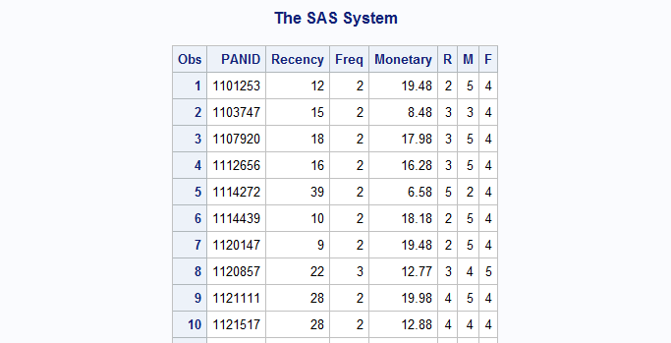

1. The customers with highest RFM values are our best customers. We get 125 total combinations in total. To properly analyse our data and segment our customers, we needed manageable clusters. This can be resolved by clustering the customers based on the R, F, and M variables
2. Standardized the R, F, M variables and segmented the customers into 3 clusters. Below are the resulting clusters:
3. Cluster 1 – Low R, Low F and Low M
4. Cluster 2 – High R, Low F and Medium M
5. Cluster 3 – High R, High F and High M
6. Cluster 3 contains most important customers and Cluster 1 consists of customers with least desirable characteristics
7. The demographic data was then merged with the cluster table to understand if there were distinct characteristics within each cluster. Note that as Gillette covers 70% of total market of razors, its clientele is equally spread across all type of customers and there is no one specific group of customers that favour a Gillette product. However, we did identify some characteristics that were more prominent in one cluster than in other. Below are our findings

|  |
| --- |
| **CLUSTER 1 - Least Desirable customers**  **Differentiating Characteristics-**   * Low R, F and M scores   **Demographics-**   * Males and Females in the age group of 25-34 * Males are high school graduates * Females are graduate from a technical school * Females are craftswomen or homemaker * Families have children in age of 6-11 |
| **CLUSTER 2 - Average Customers**  **Differentiating Characteristics-**   * High R, Low F and Medium M scores.   **Demographics-**   * Males with medium income and Professional or Technical occupation * Females with age between 25-34 and with age 65 or more * Females are college graduates * Females have clerical jobs * Customers are single * Gillette Mach and Gillette Venus are favored products |

|  |
| --- |
| **CLUSTER 3 – Most Desirable Customers (Loyal Customers)**  **Differentiating Characteristics-**   * High R, F and M scores   **Demographics-**   * Males have either operative or craftsman jobs * Females are in the age group of 45-54 * Females have cleared high school * Females are in Food and Health services * Customers are divorced * Gillette Sensor excel, Gillette Custom plus, Gillette Daisy, Gillette Atra, Gillette Good news are the favored products |

This information could be used either to build predictive models to categorize future customers or to identify customers to target for a marketing campaign.

**Recommendations:**

1. Use the RFM model created to cluster target customers based on the cluster characteristics:
2. Cluster 1 and 2 comprise of customers who score low on recency and frequency, and should be targeted with bundled packs with less expensive products at a discounted rate
3. Customers in cluster 3 comprise of high value customers and should be targeted with discounts on the high-end products and loyalty programs

**Analysis 5**

**Objective:**

To gauge the effect of Gillette sales by competitor brands and products by measuring the cross-brand elasticity and the cross-product elasticity.

1. Cross-brand elasticity

A regression model was run to measure the overall Gillette sales considering the weighted Gillette brand price and the weighted Schick brand price. The output model had a bad model fit and had insignificant coefficients at a 95% confidence level.

Below is the output for the regression:

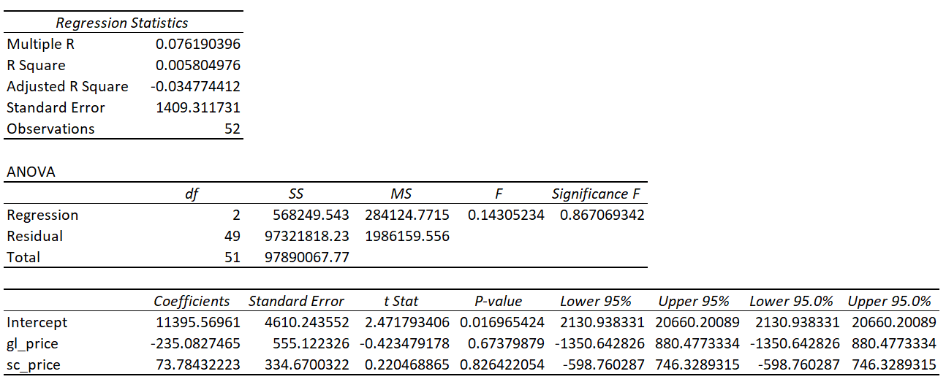

1. Cross-product elasticity

A regression model was run to measure the overall Gillette sales considering the weighted Gillette product price and the weighted Schick product price. The output model had a bad model fit and had insignificant coefficients at a 95% confidence level.

Below is the output for the regression:

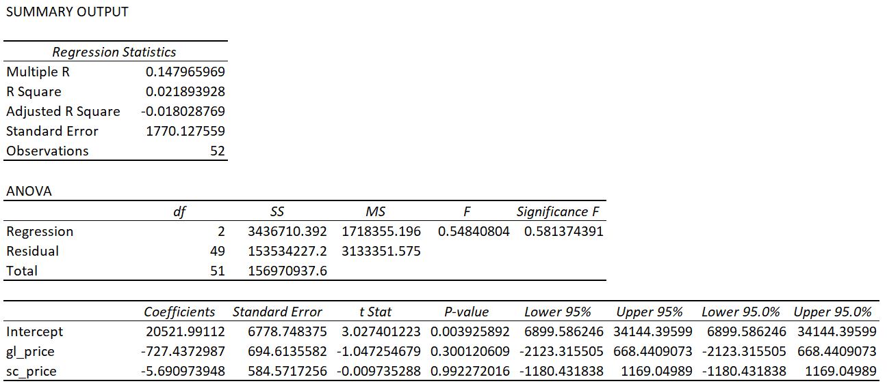

**Findings:**

1. Gillette has positioned itself such that price fluctuations in competitor brand price and competitor product price have no effect on Gillette sales.